**Hierarchical Task Graphs**

Ordering Food Items

1. Order dishes
2. Start the application
3. Dishes selection
   1. Customer type
      1. First time customer
      2. Return customer
   2. Select ordering type
      1. DIY ordering
      2. Combo ordering
   3. Menu actions
      1. Menu type selection
      2. Order action
         1. Add dishes
         2. Delete dishes
         3. Clear all selected dishes
4. Summary page
   1. Confirm the order
      1. View selected dishes
      2. View total amount of calories
      3. View allergy warning
      4. View special food material
      5. Modify the order in Dishes Selection interface
   2. Enter addition information
      1. Enter No. of customers
      2. Choose tableware type
      3. Child seat needed
      4. Enter other information
5. Finished the order

Plan 0: Do 1-2-3-4

Plan 2: Do 2.1-2.2-2.3.

Plan 2.1: Do 2.1.1 if it’s the first time that customers come to the restaurant. Do 2.1.2 if customers have been the restaurant before.

Plan 2.2: Do 2.2.1 if customers want to select dishes by themselves. Do 2.2.2 if customers want a combo, because it’s the easiest way to order dishes, and it won’t go wrong.

Plan 2.3: If customers want to choose different type of the menu, then order the food, do 2.3.1-2.3.2. If customers want to use the default menu to order the food, do 2.3.2.

Plan 2.3.2: If customers want to add some dishes from the menu, do 2.3.2.1. If customers want to delete some of dishes, do 2.3.2.2. If customers want to delete all dished that already ordered, do 2.3.2.3.

Plan 3: Do 3.1-3.2.

Plan 3.1: If customers want to modify the order, do 3.1.1-3.1.2-3.1.3-3.1.4-3.1.5. Otherwise, do 3.1.1-3.1.2-3.1.3-3.1.4.

Plan 3.2: If customers take baby, then do 3.2.1-3.2.2-3.2.3. If customers have addition comment to chefs or attendants, do 3.2.1-3.2.2-3.2.4. Normally, customers should do 3.2.1- 3.2.2.

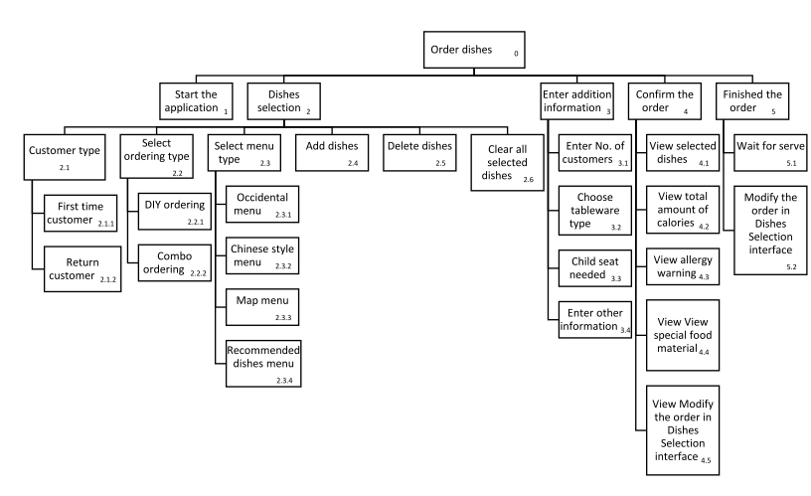

Paying the Bill

1. Pay the Bill
2. Enter coupon code
3. View order’s summary
   1. View dishes price individually
   2. View total amount of the order
   3. View PST and GST
   4. View service charge (for 10 people or more)
4. Choose payment type
   1. Cash
      1. Change funds
      2. No change
   2. Card
   3. Add tips
5. Payment status
   1. Completed payment
   2. Incomplete payment
      1. Change payment type
      2. Try pay it again

Plan 0: Do 2-3-4. If customers have our restaurant’s coupon code, do 1-2-3-4. If customers want to take leftovers, do 2-3-4-5. If customers want to give some suggestion or say something to our staff, do 2-3-4-5.

Plan 2: Do 2.1-2.2-2.3. If customers numbers are more than 10 people, then there is a mandatory service charge, do 2.1-2.2-2.3-2.4.

Plan 3: If customers pay by cash, do 3.1, if they want to give tips, do 3.1-3.3. If customers prefer to pay by card, do 3.2, if they want to add some tips, do 3.2-3.3.

Plan 3.1: If customers give more money than total amount, and want to get the change, do 3.1.1. If customer give more money than total amount but don’t need change, or paid exact amount of the bill, do 3.1.2.

Plan 4: Do 4.1 if the payment is done successfully. If the payment is rejected, do 4.2.

Plan 4.2: If customers want to change payment method, do 4.2.1. If customers want to try to pay the bill with same payment method as last time, then do 4.2.2.

图片包含 屏幕截图

已生成极高可信度的说明

View Restaurant Statistic

1. View restaurant statistic
2. Enter the password
   1. Correct password
   2. Incorrect password
      1. Re-enter the password
      2. Enter too many times password
   3. Forgot the password
3. View restaurant statistic
   1. View dishes inventory
   2. View order statistic
4. Quit statistic interface

Plan 0: Do 1-2-3 if the user want to view the restaurant statistic after enter the correct password. If the user enter this page by mistake, do 3. If the user didn’t enter the correct password, do 1-3.

Plan 1: Do 1.1 if the user enter the correct password. Do 1.2 if the user enter the incorrect password. Do 1.3 if the user forgot the password, then the user will get the hint of the password.

Plan 1.2: Do 1.2.1 if the user want to enter the password again after enter the incorrect password. Do 1.2.2 if the user already enter too many times incorrect password.

Plan 2: Do 2.1 if the user wants to view the inventory of dishes. Do 2.2 if the user wants to view order statistic. Do 2.1 and 2.2 if the user wants to view both kind of data.

